**Project 7 Coin Detection with OpenCV**

Name: Arnav Jain Period: 3 Date: 03/27

Did you name your file l071.cpp (Lower case L, then 071)? yes

Did you use OpenCV to detect coins? yes

Did you test your code on terminal/gnu linux in c++11? yes

What functions/methods from OpenCV did you use?

HoughCircles  
CannyEdge

medianBlur

cvtColor

imwrite, imread

__________________________________________________________________________________

What functions/methods from OpenCV did you experiment with but ended up not using?

HoughLines

SobelX, SobelY, SobelXY

GaussianBlur

Run your code (the same code you submit) on the 3 images I provided (easy, medium, hard) then paste here the following:

* The initial image ( the one I provided), the imageg.jpg, imagef.jpg, coins.jpg you obtained running your code, copy paste here the content of your results.txt file your code created

1. For the easy image:

Command line including all parameter values used for this image:

./l071 -F image.jpg -S 97 -T 80 -M 130 -TC 50

(F is input image, S is size of Penny, T is upper threshold for Canny, M is maximum coin size)

Initial image: 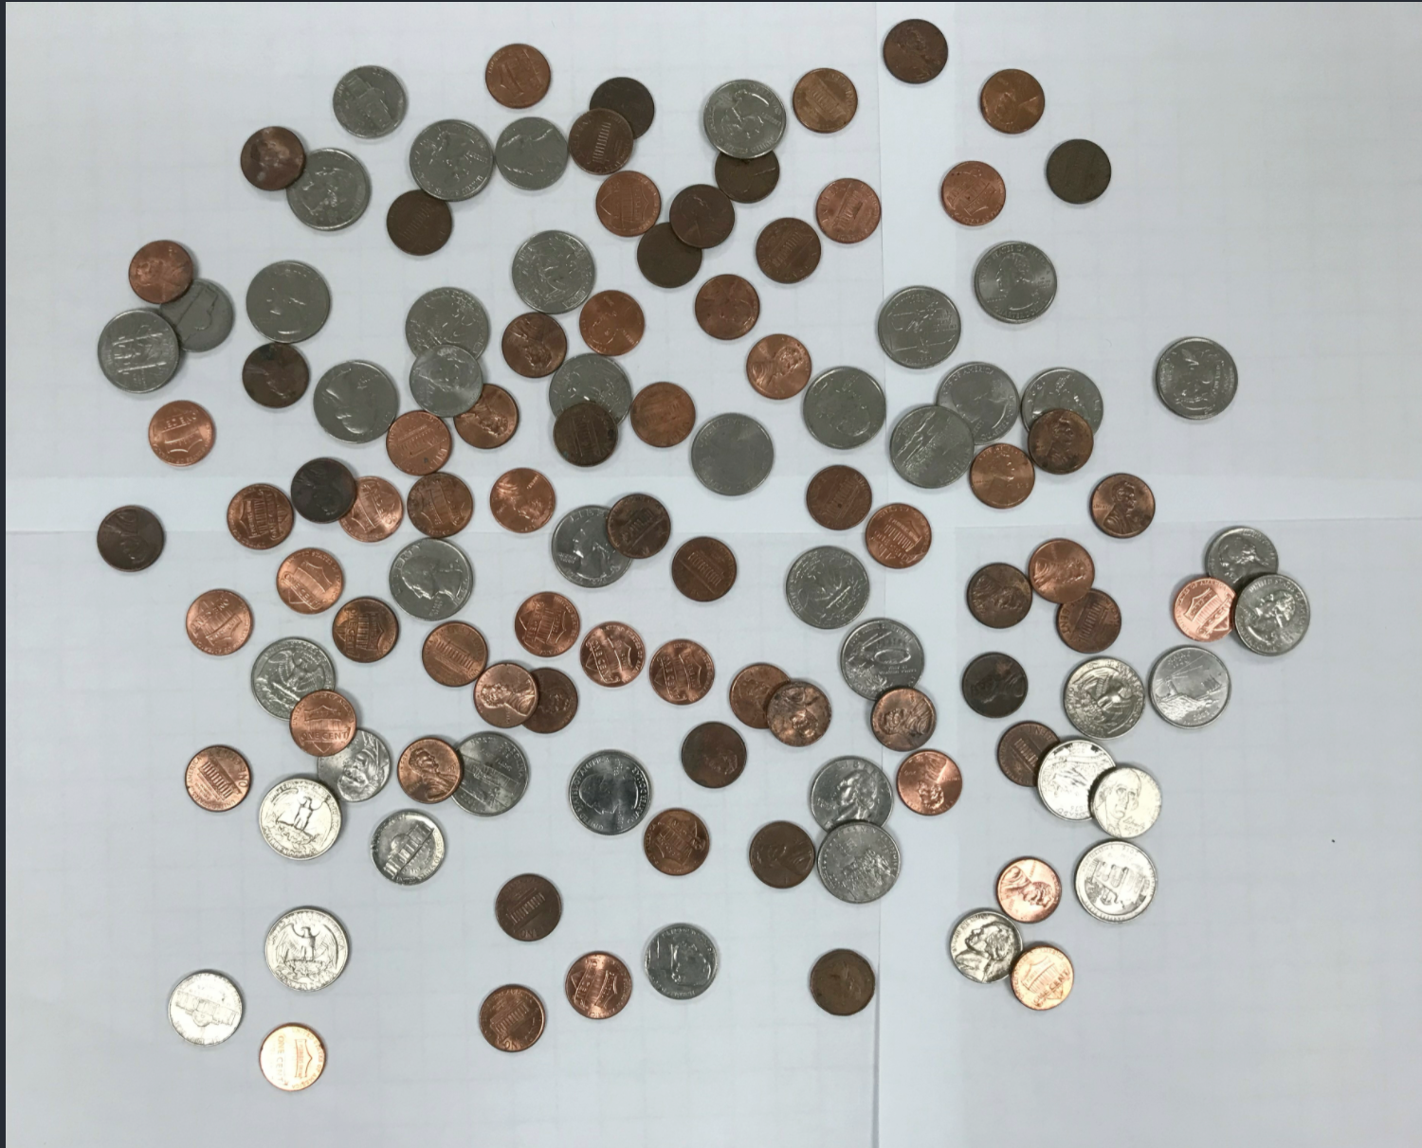

imageg,jpg:

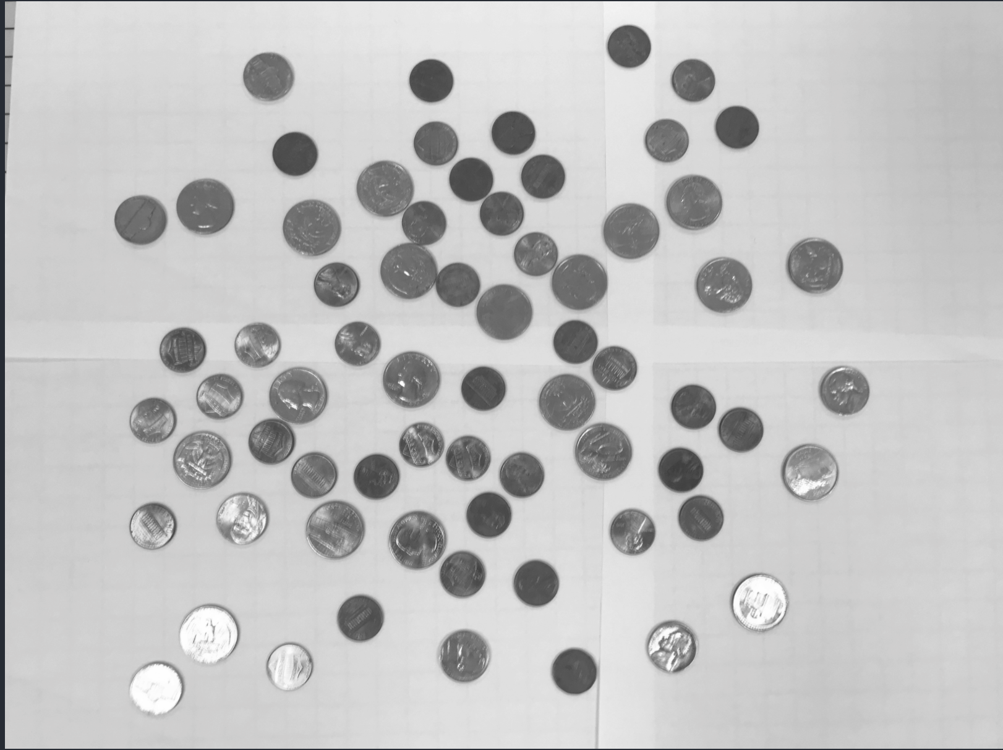

imagef.jpg:

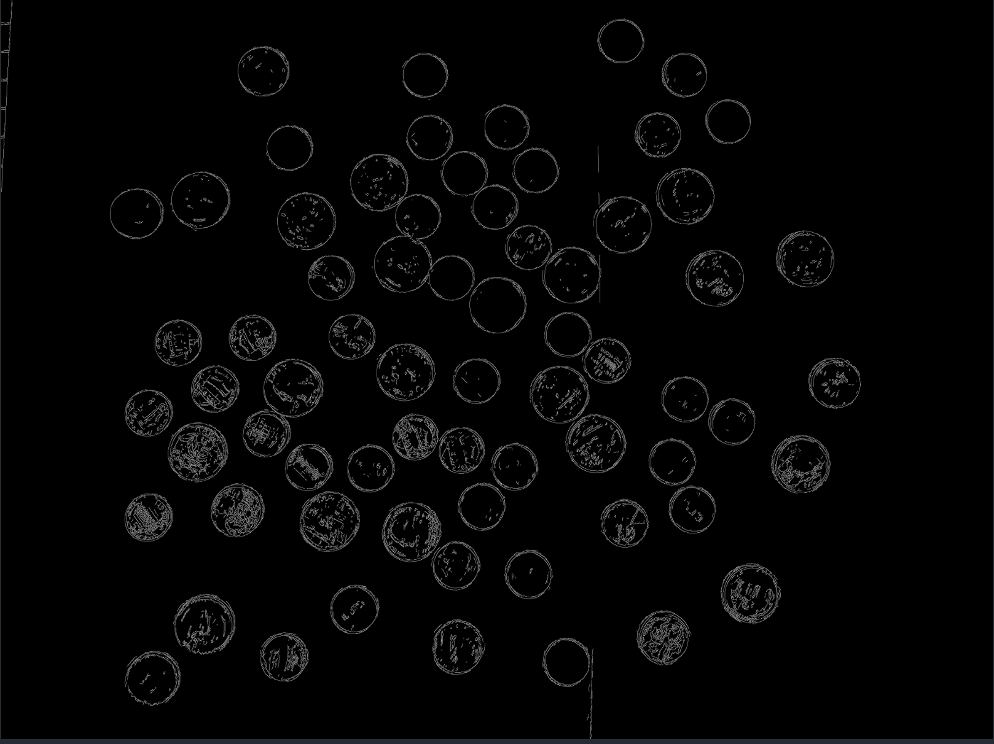

coins.jpg:

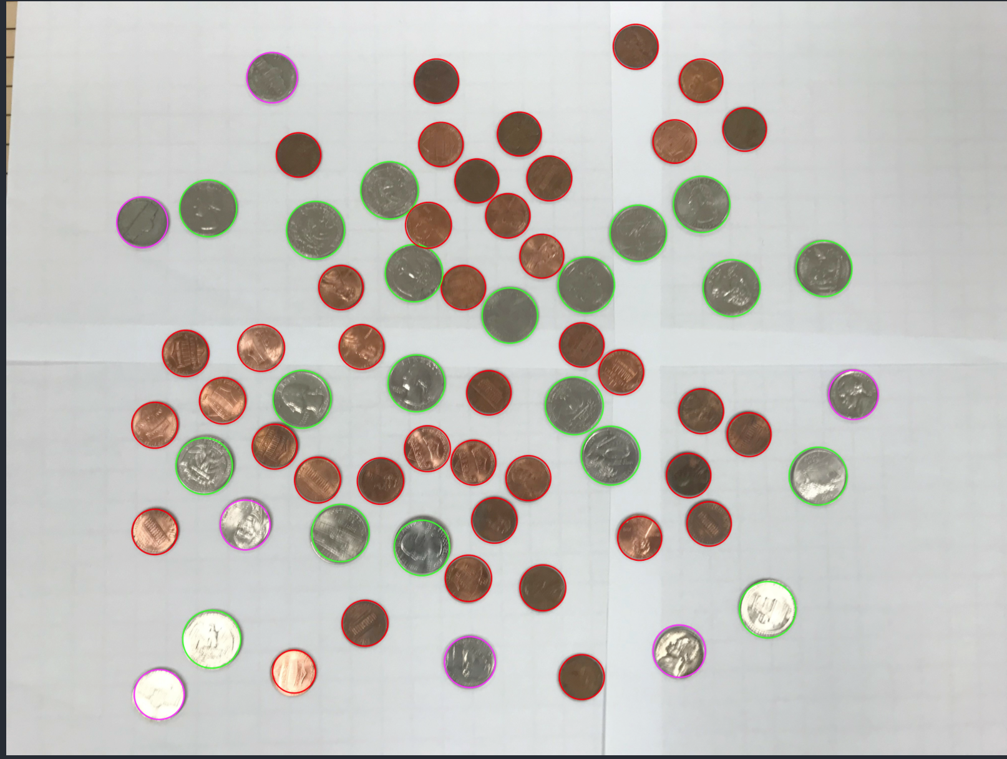

Content of results.txt:

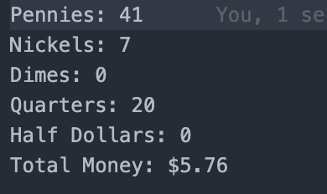

1. For the medium image:

Command line including all parameter values used for this image:

./l071 -F image.jpg -S 92 -T 80 -M 130 -TC 50

Initial image:

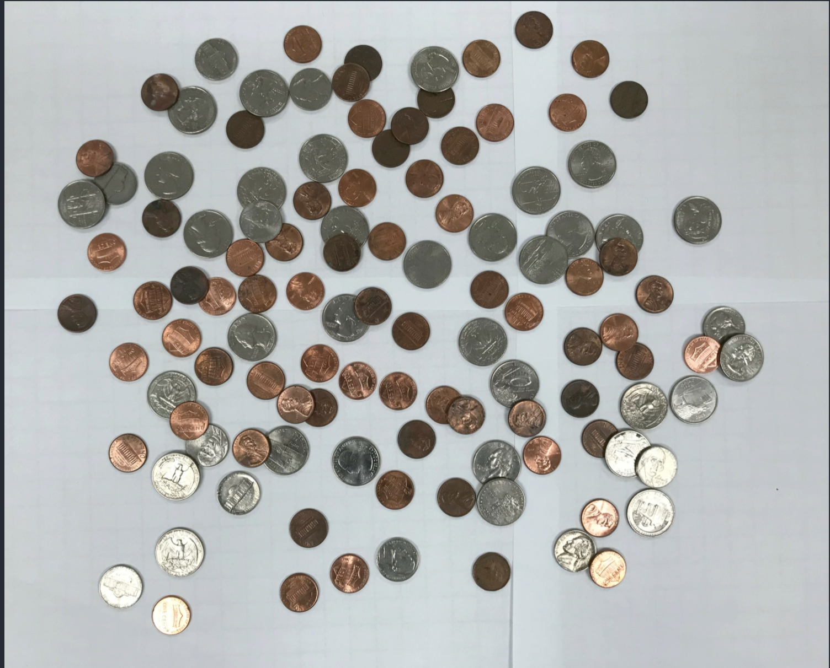

imageg,jpg:

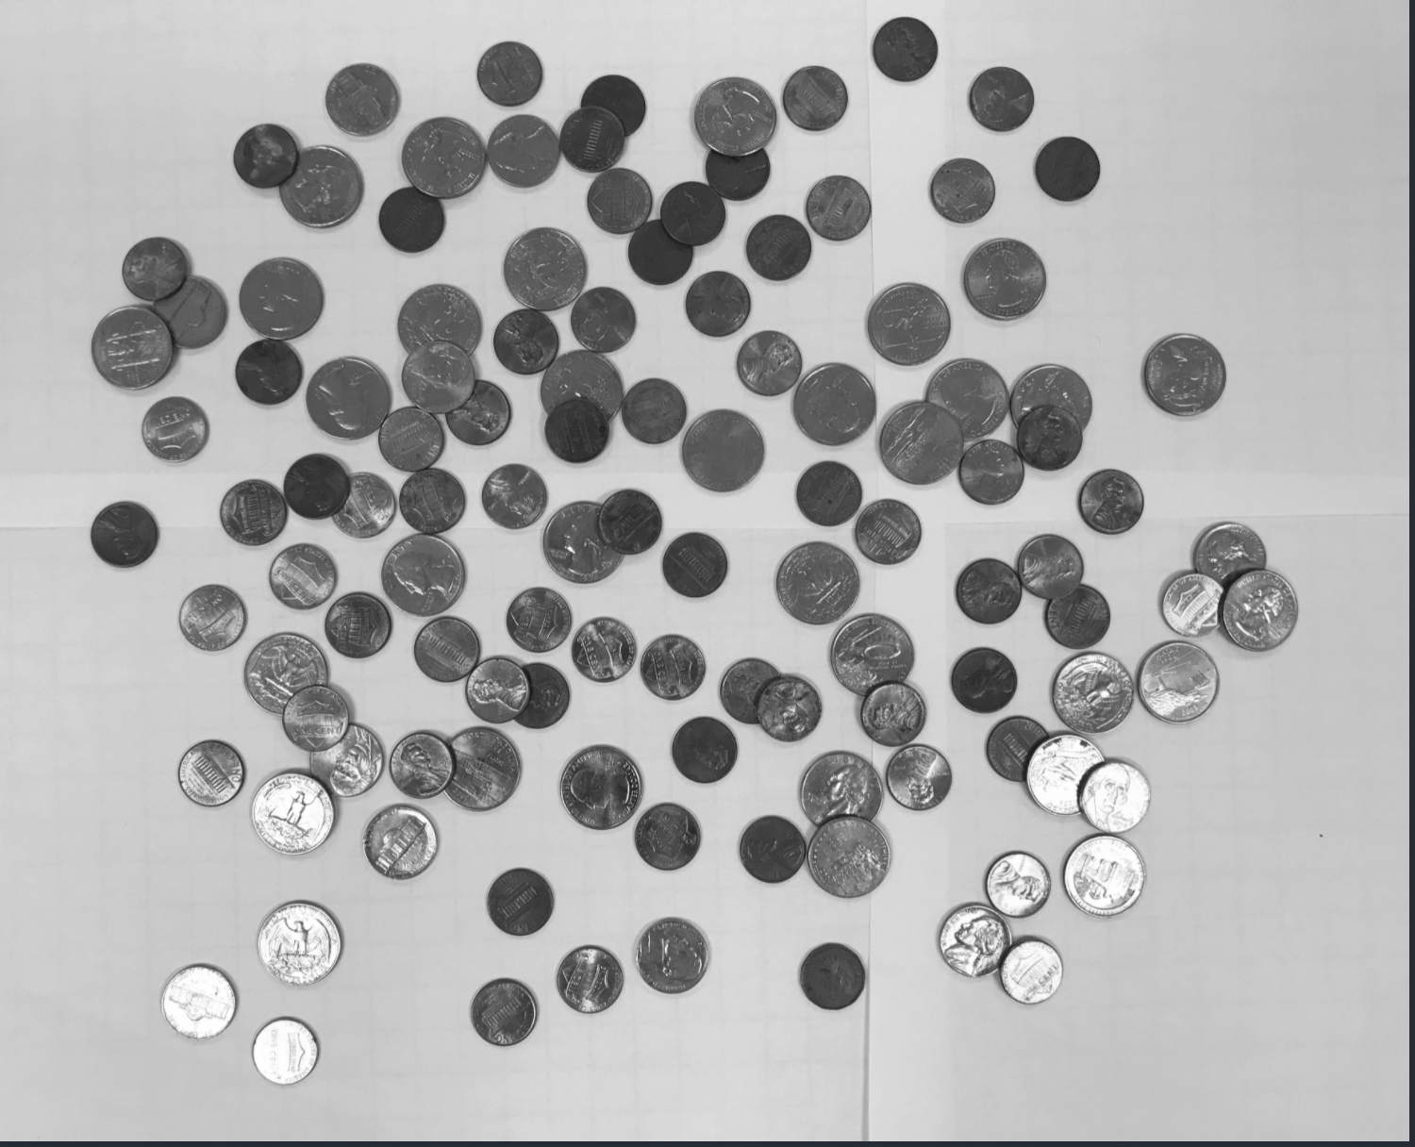

imagef.jpg:

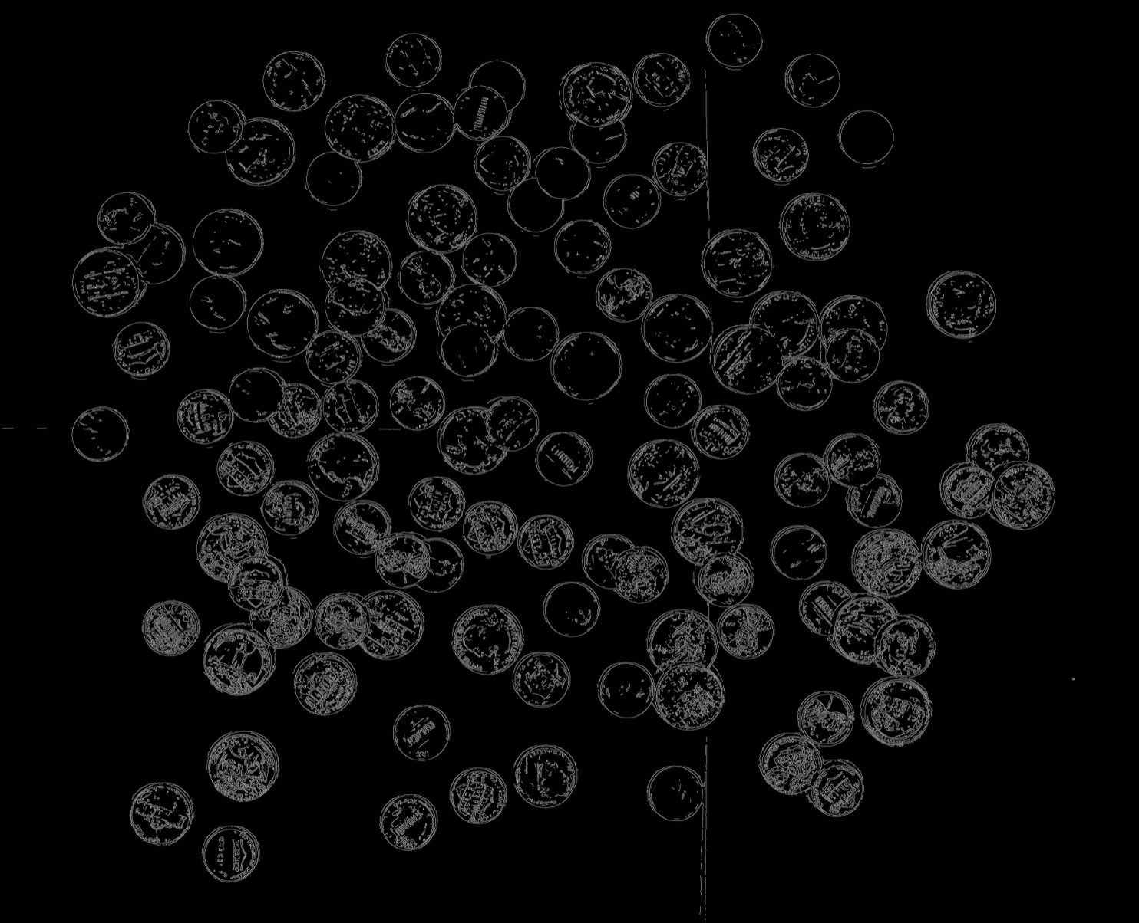

coins.jpg:

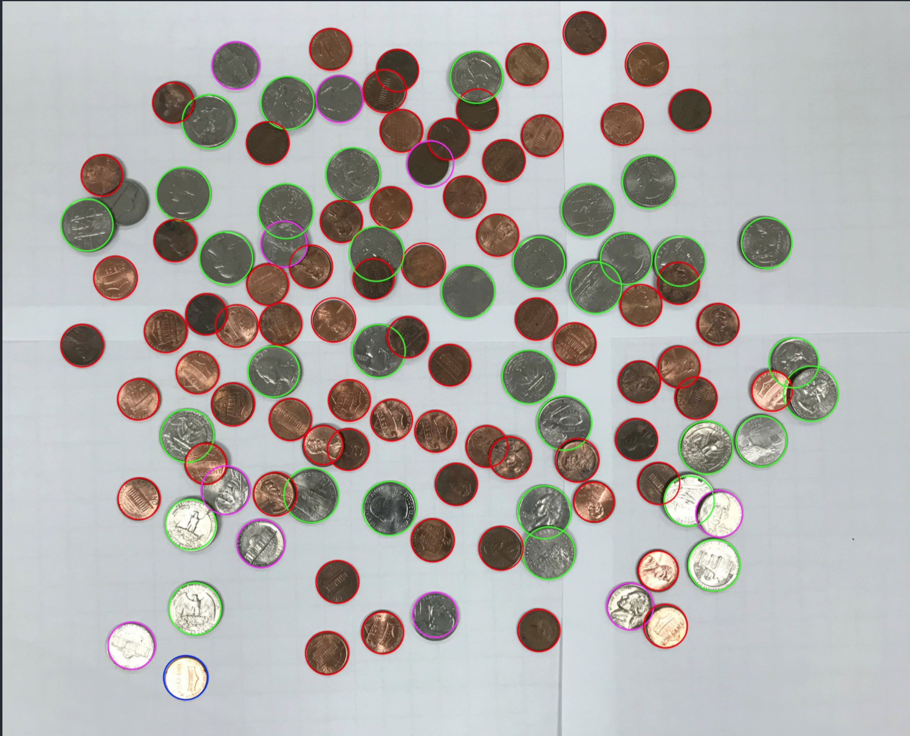

Content of results.txt:

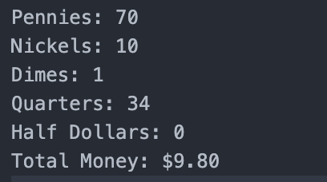

1. For the hard image:

Command line including all parameter values used for this image:

./l071 -F imagehard.jpg -S 91 -M 110 -T 65 -TC 45

Initial image:

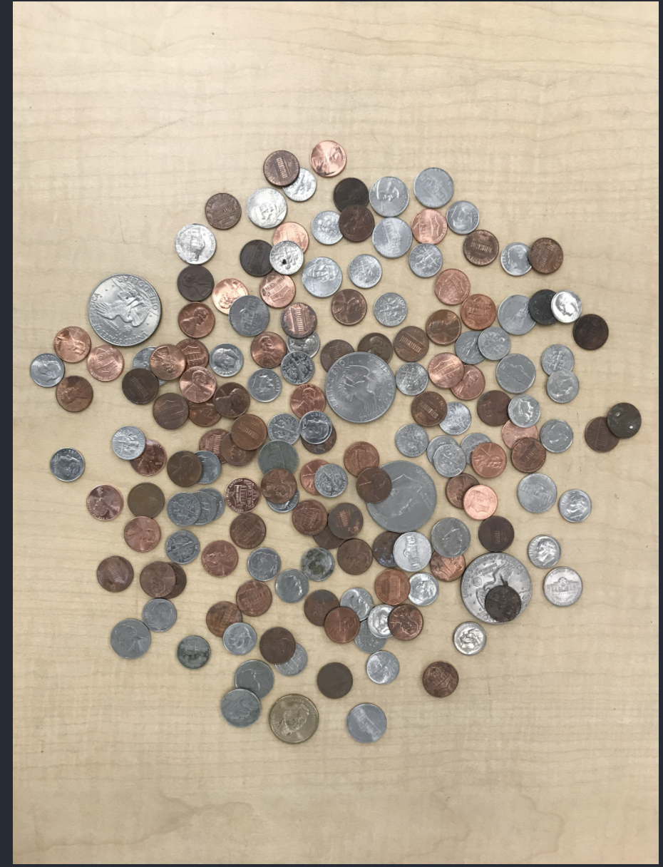

imageg,jpg

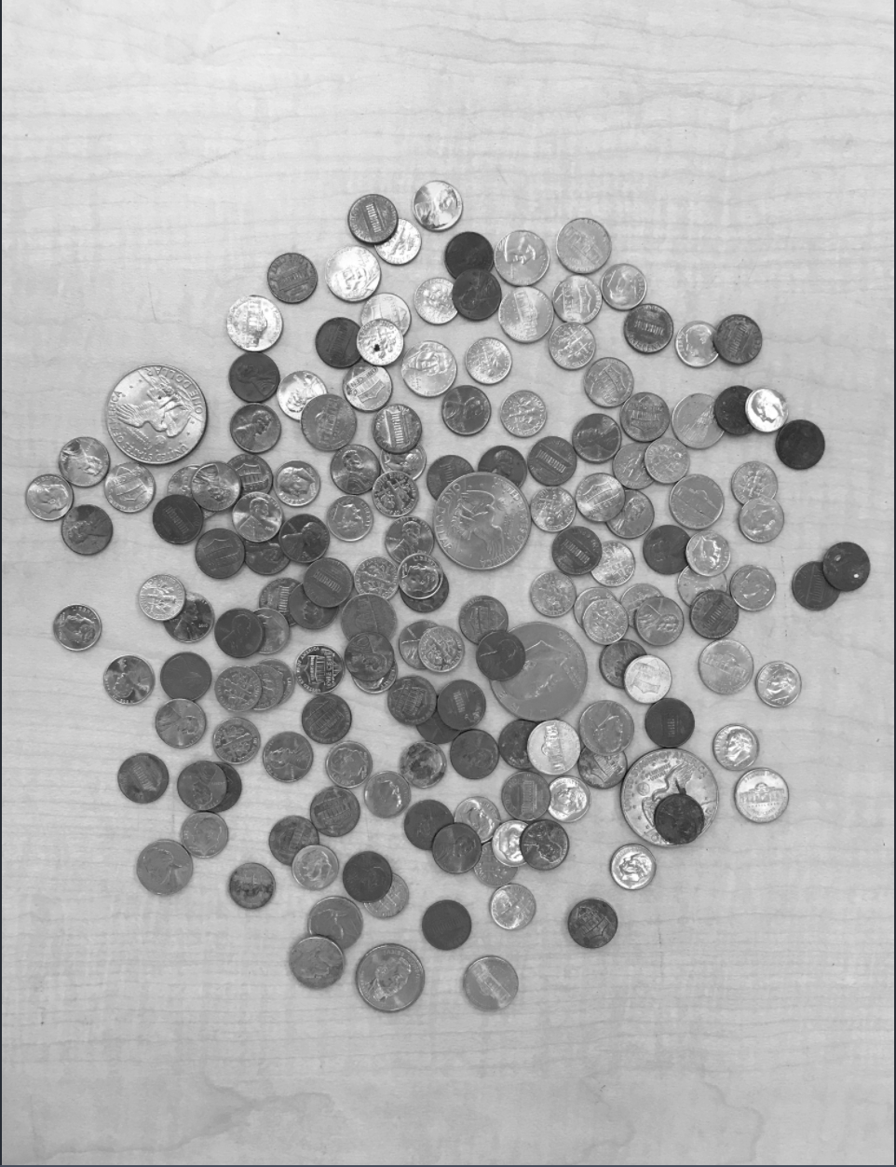:

imagef.jpg:

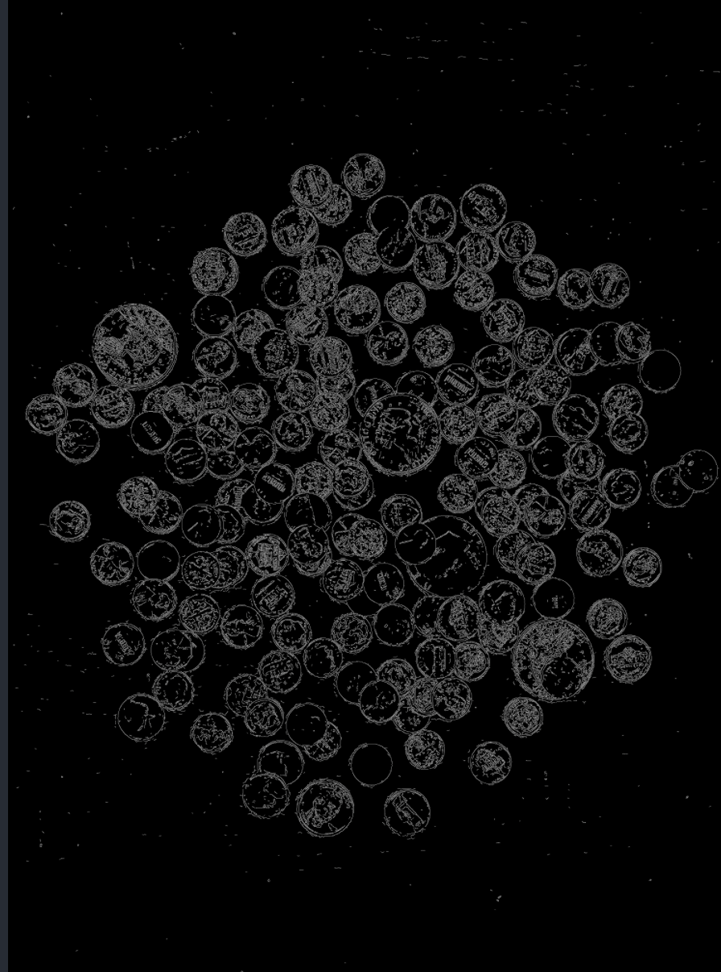

coins.jpg:

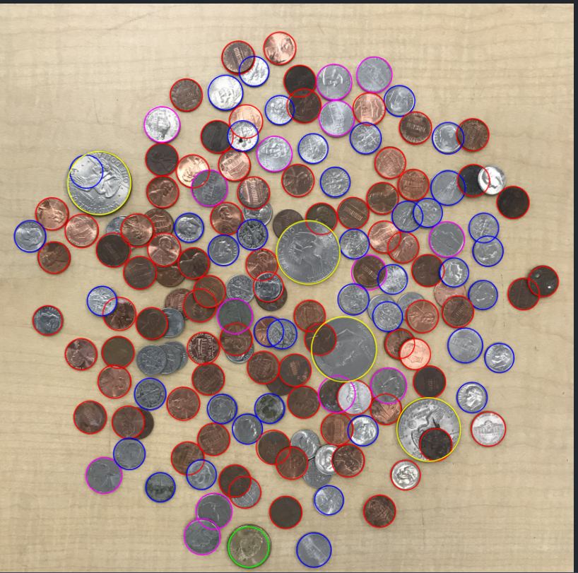

Content of results.txt:

